|  |  |
| --- | --- |
| **Num of CPUs** | **Elapsed Time (Seconds)** |
| 1 | 0.13 |
| 2 | 0.29 |
| 4 | 0.39 |
| 8 | 0.50 |

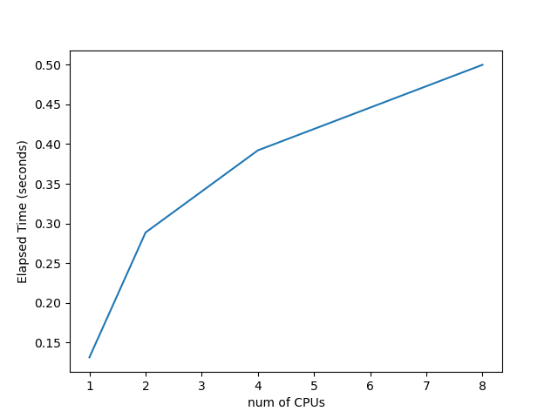

As the number of CPUs went from less to more, the elapsed time also increased. That is, more CPUs do not achieve the expected speedup.

Guess 1: The number of iterations is only 100, which is very small, so the error will be large.

Guess 2: As more CPU cores are used, each CPU core slows down as more are used, also generates more overhead.

Guess 3: Contention for cache memory and contention for main memory—CPU cores are forced to wait on main memory (far slower than registers).